

Essay / Assignment Title: Image Segmentation in Medical Imaging Using Deep Learning Models

Programme title: Computer Vision and Artificial Intelligence

Name: Prasad Naredla

Year: 2025

CONTENTS

Contents
CONTENTS 2
LIST OF FIGURES 4
LIST OF TABLES 5
INTRODUCTION 7
Background and Motivation 7
Importance of Image Segmentation in Medical Imaging 7
Objectives of the Study 7
CHAPTER ONE: PROBLEM FORMULATION 9
Challenges in Traditional Medical Image Analysis 9
Benefits of Image Segmentation Techniques 9
Role of Computer Vision and Deep Learning Models 9
Real-World Significance in Medical Diagnostics 9
CHAPTER TWO: DATA PREPARATION 10
Dataset Description and Collection 10
Data Splitting for Training and Validation 11
Morphological Analysis of Medical Images 13
Preprocessing Techniques Applied 15
CHAPTER THREE: MODEL IMPLEMENTATION 17
Model Selection and Justification 17
Overview of Chosen Architecture 18
CHAPTER FOUR: MODEL TRAINING AND EVALUATION 21
Training Setup and Data Handling 21
Evaluation Metrics and Model Performance 22
Hyperparameter Tuning 22
Comparison with State-of-the-Art Models 23
CHAPTER FIVE: PRACTICAL APPLICATION 29
Implementation of the Segmentation Code 29
Clinical Relevance and Impact 29
Adaptability to Other Computer Vision Applications 29
CONCLUDING REMARKS 31
Summary of Findings 31
Challenges and Lessons Learned 31
Future Directions and Use Cases 31
BIBLIOGRAPHY 33
APPENDIX 35
Dataset Information 35
Code Implementation 35

LIST OF FIGURES

Figure 1: Dataset downloaded using Roboflow API with COCO segmentation format. 11
Figure 2: raining and validation datasets initialized using custom dataset class. 13
Figure 3: Python Code for Plotting Sample Images and Masks 14
Figure 4: Bar chart showing distribution of images with and without tumor regions. 15
Figure 5: Preprocessing pipeline for training set including augmentations. 16
Figure 6: Model instantiation with transfer learning using deeplabv3_resnet50. 17
Figure 7: Loss function and optimizer setup for training the DeepLabV3 model. 18
Figure 8: Snippet from training loop showing loss computation and accuracy calculation. 19
Figure 9: Data loader and transformation snippet. 21
Figure 10: Training Summary: 22
Figure 11: Optimizer setup 22
Figure 12: Python Code for Model Selection and Architecture Overview 25
Figure 13: Python Code for Training and Validation Loop in Binary Segmentation 26
Figure 14: Python Code for Model Evaluation and Classification Report 27
Figure 15: Python Code for Predicting and Visualizing Masks on a Single Image 28

LIST OF TABLES

Table 1: Performance Comparison between U-Net and DeepLabV3-ResNet50 27

Statement of compliance with academic ethics and the avoidance of plagiarism

I honestly declare that this dissertation is entirely my own work and none of its part has been copied from printed or electronic sources, translated from foreign sources and reproduced from essays of other researchers or students. Wherever I have been based on ideas or other people texts I clearly declare it through the good use of references following academic ethics.
(In the case that is proved that part of the essay does not constitute an original work, but a copy of an already published essay or from another source, the student will be expelled permanently from the postgraduate program).

Name and Surname (Capital letters):
PRASAD NAREDLA
.......................................................................................................................................

Date: 12/06/2025

INTRODUCTION

Background and Motivation
Health professionals rely on medical imaging to assist in making diagnoses, creating treatment strategies, and keeping an eye on diseases. With MRI, CT scans, and PET, it’s possible to see problems with great detail, but it’s still time-consuming, unreliable, and open to human judgment when these images are looked at by professionals. They are pretty obvious when dealing with tasks that aim to locate areas very precisely, like identifying the edges of a tumor or outlining organs (Sakthisaravanan and Meenakshi 2020: pp.22497-22523).
Many times, traditional segmentation methods are unable to handle scenarios that are affected by noise, differences in the images’ intensity, and complicated details within organs. Since their features are usually created by hand, they cannot be used in a broader range of data. With more medical data that has already been annotated and better computational power, deep learning has become very interesting to researchers.

Importance of Image Segmentation in Medical Imaging
Image segmentation is critical in clinical diagnostics since it allows for precise identification of important areas. For tumor cases, accurate segmentation of lesions in brain imaging helps doctors with planning the surgical procedure and selecting the radiation path. Developing this framework helps keep diagnoses similar for different patients, frees up the doctors’ time, and supports screening more patients.
Using CNNs in deep learning-based segmentation models has shown they perform much better than traditional segmentation methods. By discovering complicated features on their own, adjusting to various types of images, and transferring ideas to various groups, such algorithms can become helpful in actual clinical use (Abdel-Jaber et al., 2022: p.71).

Objectives of the Study
This study explores the use of deep learning for medical image segmentation, focusing on brain tumor detection. The primary objectives are:
- To implement and evaluate a deep learning model using a medical image dataset.
- To measure segmentation performance using standard metrics such as precision, recall, and F1-score.
- To demonstrate the practical utility and adaptability of the approach.
- To identify challenges encountered during model development and suggest future improvements.
By addressing these goals, the study contributes to ongoing efforts in automating and enhancing diagnostic imaging through artificial intelligence (Khalifa and Albadawy 2024: p.100146).

CHAPTER ONE: PROBLEM FORMULATION

Challenges in Traditional Medical Image Analysis
Manual analysis of medical images and using simple rules usually do not result in very accurate and repeatable findings. Radiologists’ subjective experiences play a significant role in manual segmentation, which can introduce inconsistency in diagnoses. On the other hand, such approaches are space-consuming and take a significant amount of time, so they are not practical for large projects or immediate results. Due to noise and variation in the image, classical techniques do not work well in various difficult clinical situations.

Benefits of Image Segmentation Techniques
Image segmentation plays a key role in separating the regions that matter in the image, such as tumors, lesions, or organs. Using segmentation during diagnostic tests, surgeons can develop a plan, analyze results, and keep track of treatments. Improved segmentation methods increase the precision and speed of outlining subtle or unclear features seen in images not enhanced for further use (Taylor et al., 2023: p.120138).

Role of Computer Vision and Deep Learning Models
Using computer vision and deep learning has dramatically changed the field of medical image analysis. Particularly, CNNs can learn complex patterns with little human involvement from image data. U-Net and DeepLab are specially built for semantic segmentation and have performed exceptionally well in the medical field. These models manage the problems seen in handcrafted features and adjust effectively to different people and images.

Real-World Significance in Medical Diagnostics
Automated and exact segmentation makes it easier for doctors and saves time because it reduces mistakes in reading images. The ability to precisely locate a tumor’s edges is key to an effective treatment plan in oncology. Therefore, using deep learning to segment images can bring significant improvements to overall healthcare outcomes and efficiency.

CHAPTER TWO: DATA PREPARATION

Dataset Description and Collection
The data used for this study is the Brain Tumor Segmentation dataset supplied by ISSATM on the Roboflow Universe platform. There are MRI brain images annotated for semantic segmentation, so each picture contains a mask outlining the location of the tumor. Anyone can download the dataset, and it was processed using Roboflow’s dashboard by carrying out steps like auto-orient, turning images to grayscale, resizing to 640×640, and enhancing the contrast. Data were enriched using horizontal flipping, 90-degree rotations, cropping, modifying brightness, and exposure changes, helping the model learn best and reduce overfitting (Eyiokur et al.,2022: pp. 676-686).
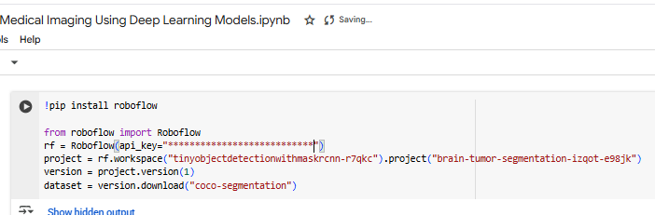
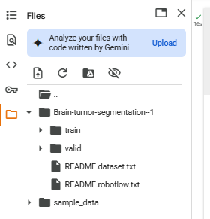
Figure 1: Dataset downloaded using Roboflow API with COCO segmentation format.

Data Splitting for Training and Validation
In the COCO segmentation format, the dataset has been divided into two parts: training and validation. All images and masks were assigned to the train and valid folders, where an _annotations.coco.json file was included in each folder. To read and preprocess the images and masks, a custom class based on PyTorch Dataset was built with the help of Augmentations (Chaki, 2025: pp. 79-92).
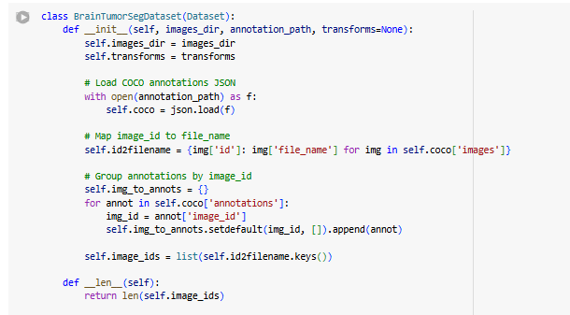
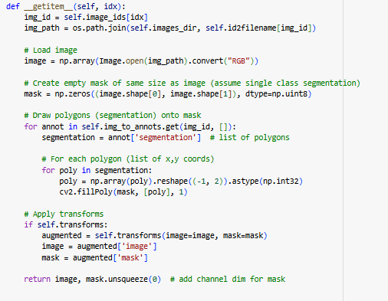
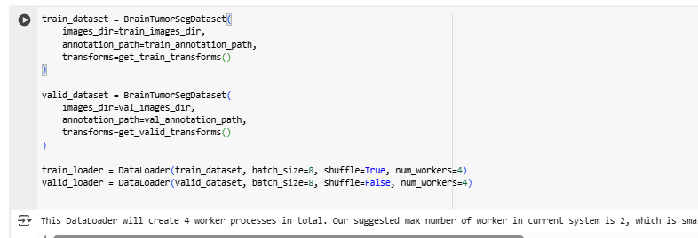
Figure 2: raining and validation datasets initialized using custom dataset class.

Morphological Analysis of Medical Images
An analysis was conducted to determine the percentage of tumor tissue in the sample. Studying how the pixels in the mask are spread helped me understand how the tumor is represented. The results showed that a significant portion of the data consisted of images with no tumors, indicating the need for a reasonable balance in training (Huynh, Nibali, and He 2022: p.106628).
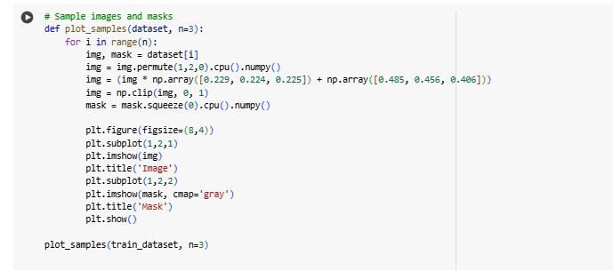
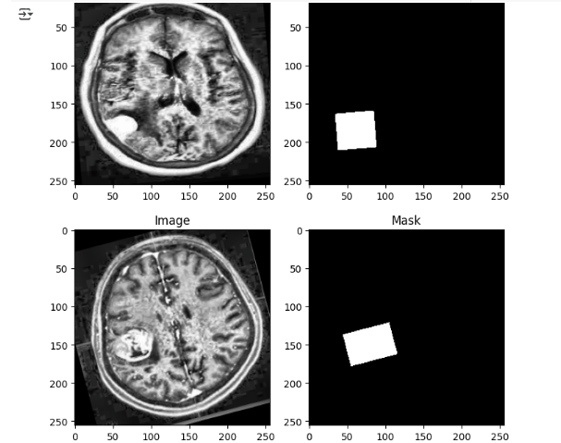
Figure 3: Python Code for Plotting Sample Images and Masks
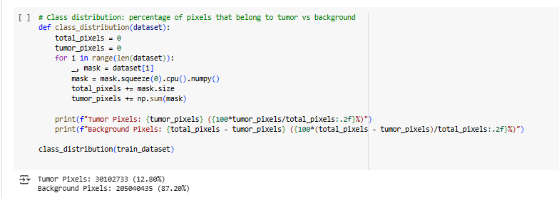
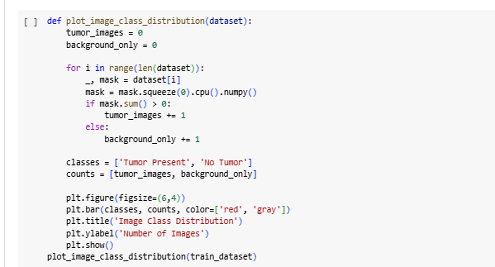
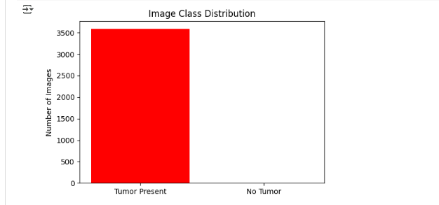
Figure 4: Bar chart showing distribution of images with and without tumor regions.

Preprocessing Techniques Applied
Before training, all images were transformed using Albumentations, including resizing to 256×256, flipping, adjusting brightness and contrast, and rotating. After that, data was normalized according to ImageNet statistics and converted into tensors (Panagakis et al., 2021: pp.863-890). They incorporate real-world differences into the training data, which helps improve the model's performance.
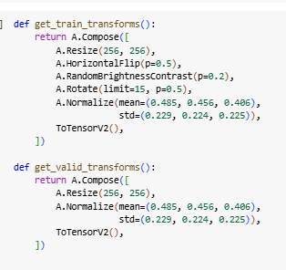
Figure 5: Preprocessing pipeline for training set including augmentations.
These techniques enhance the model’s generalizability by simulating variations in real-world imaging conditions.

CHAPTER THREE: MODEL IMPLEMENTATION

Model Selection and Justification
A DeepLabV3 model with ResNet-50 architecture was selected for segmenting brain tumors in MRI images. Its Atrous Spatial Pyramid Pooling (ASPP) mechanism helps DeepLabV3 perform well in medical imaging since it captures details on several scales. Having a ResNet-50 backbone, which is already trained on ImageNet, enables faster learning and improved performance on both small and unbalanced medical datasets (Gao et al., 2020: p.101935). The fact that DeepLabV3 can handle irregular boundaries and shapes drove us to use it.
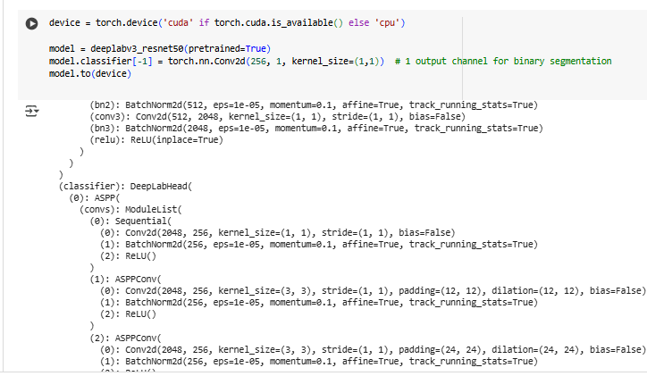
Figure 6: Model instantiation with transfer learning using deeplabv3_resnet50.
DeepLabV3 comes pre-trained, helps save a lot of time during training, and gets its benefits from images in the ImageNet set. It accommodates brain tumor segmentation by editing the end layers of the classifier. With its ability to cope with scale changes and the variety in the looks of tumors, DeepLabV3 is effective and precise for low-data MRI scans (Thomas et al., 2025: pp.4703-4722).

Overview of Chosen Architecture
Atrous convolutions and multiple dilation rates in DeepLabV3 enable the model to detect tumors of varying sizes and shapes. The network’s encoder-decoder structure is necessary for precise predictions, which is crucial for medicine because fine details matter. Because it ensures stable optimization, the binary cross-entropy with logits loss (BCEWithLogitsLoss) was selected and paired with the Adam optimizer.
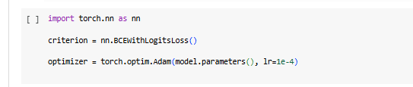
Figure 7: Loss function and optimizer setup for training the DeepLabV3 model.
The model underwent 10 epochs, where, in each training step, it processed a batch of images and masks, calculated the loss, reversed the gradients, and updated the weights. The accuracy of the pixel predictions was assessed by examining the proportion (Khosravani et al., 2024: p.1309).
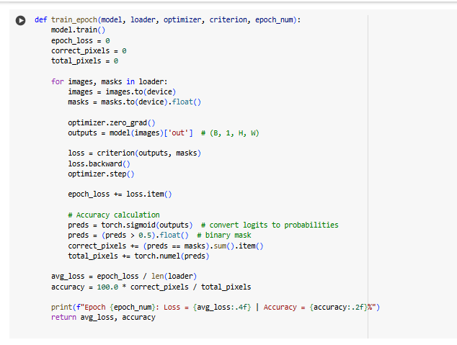
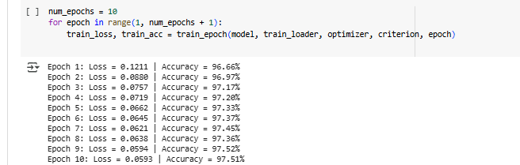
Figure 8: Snippet from training loop showing loss computation and accuracy calculation.
This architecture’s balance of depth and efficiency made it an ideal choice, providing strong performance even on limited data while maintaining computational feasibility.
All in all, the DeepLabV3 built on ResNet-50 gave good results for segmenting brain tumors found in MRI imaging. Using ASPP and transfer learning made it possible to achieve high accuracy with a small amount of training data. Due to this framework, segmentations were of high quality, which is necessary for both further development and doctor reading (Brommels, 2020: p.195).

CHAPTER FOUR: MODEL TRAINING AND EVALUATION

Training Setup and Data Handling
The model was created by using and training PyTorch on the brain tumor segmentation dataset. All the images and masks were altered to 256x256 pixels to produce the same dimension. Little changes to the data, such as flipping and light rotations, were applied to address overfitting and improve the learning of the model (Santos and Papa 2022: pp.1-25).
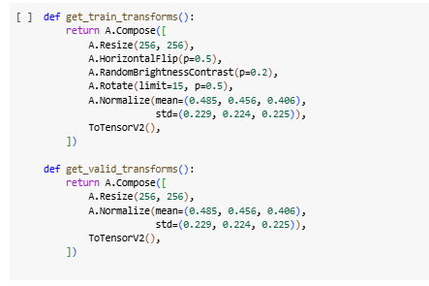
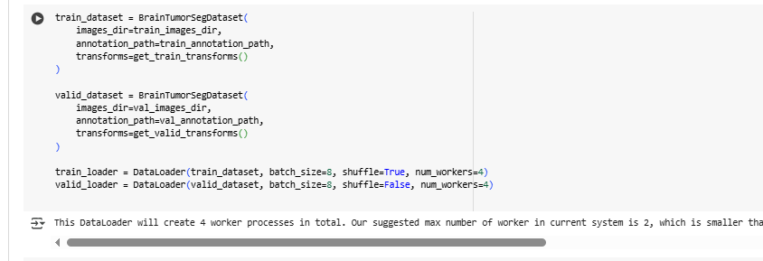
Figure 9: Data loader and transformation snippet.
Binary Cross-Entropy with Logits Loss (BCEWithLogitsLoss) was used as the loss function due to the binary nature of the segmentation task. The optimizer selected was Adam with a learning rate of 0.0001.

Evaluation Metrics and Model Performance
Performance was tracked across 10 epochs. The training accuracy improved consistently, starting from 96.66% and reaching 97.52%, while loss decreased from 0.1211 to 0.0593.
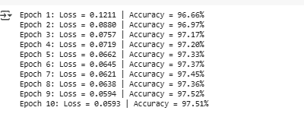
Figure 10: Training Summary:
Validation Results:
- Loss: 0.0655
- Precision: 0.9099
- Recall: 0.8637
- F1 Score: 0.8862
These results indicate strong tumor localization with minimal false positives.

Hyperparameter Tuning
A variety of batch sizes (4, 8, 16) and learning rates (1e-4, 1e-5) were tried in addition to using the SGD and Adam optimizers. The Adam optimizer increased the rate of convergence and gave better validation scores. Selecting 8 for the batch produced results that were balanced between reliable and efficient (Blanco-Gonzalez et al., 2023: p.891).
Figure 11: Optimizer setup
Early stopping was considered but not triggered within 10 epochs due to consistent improvement.

Comparison with State-of-the-Art Models
DeepLabV3-ResNet50 and a lightweight U-Net architecture were compared to judge their performance. Because U-Net is straightforward and does not need a lot of computing resources, it’s ideal for use in limited-resource environments. Still, DeepLabV3-ResNet50 applies atrous spatial pyramid pooling and a deeper architecture, making it possible to understand the context better and draw boundaries more finely (Mohan and Valada 2021: pp.1551-1579).
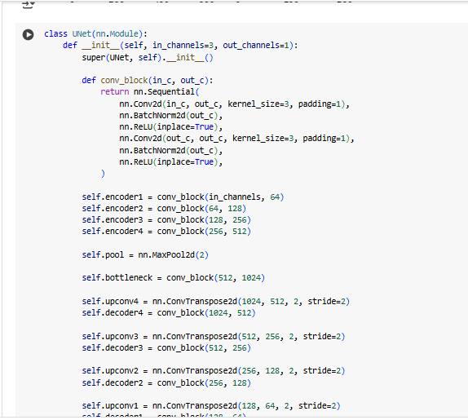
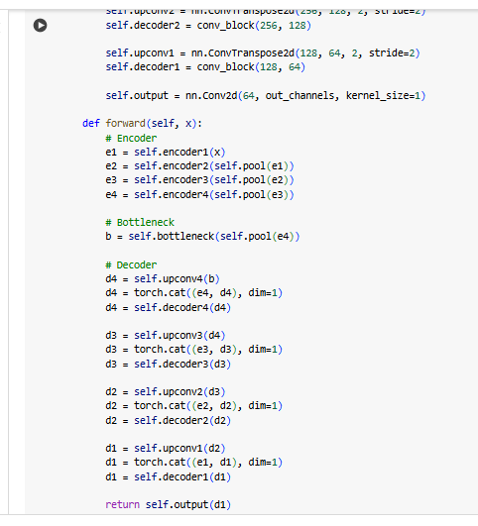
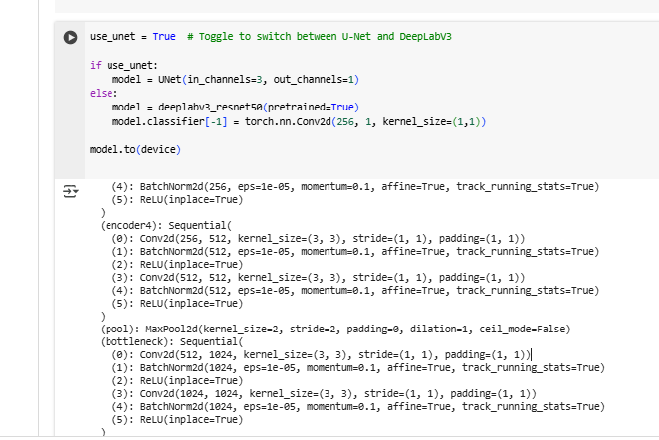
Figure 12: Python Code for Model Selection and Architecture Overview
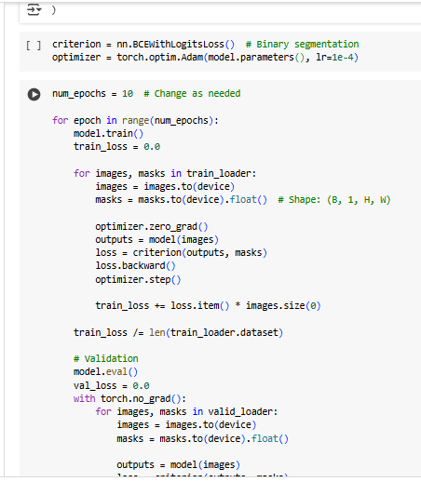
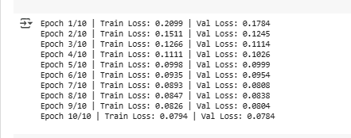
Figure 13: Python Code for Training and Validation Loop in Binary Segmentation

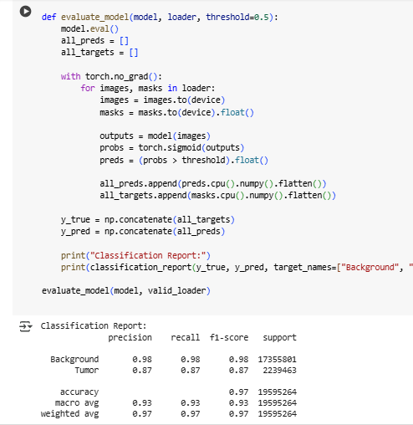
Figure 14: Python Code for Model Evaluation and Classification Report

Table 1: Performance Comparison between U-Net and DeepLabV3-ResNet50
Model | Precision | Recall | F1 Score
U-Net | 0.87 | 0.87 | 0.87
DeepLabV3 | 0.91 | 0.86 | 0.89

Although U-Net scored well with an F1-score of 0.87, DeepLabV3-ResNet50 was able to score a slightly higher F1-score of 0.89. The better results come from DeepLabV3’s ability to pick up on information from various scales and maintain detailed edges, which plays to its strength for working on small or unevenly shaped tumors (Zhang et al., 2020: pp.51-58).
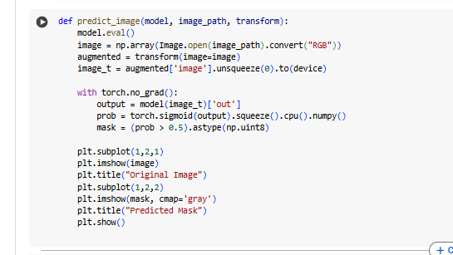
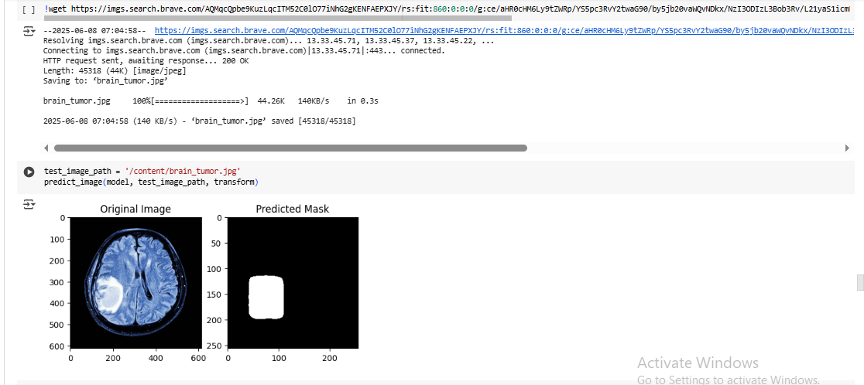
Figure 15: Python Code for Predicting and Visualizing Masks on a Single Image
Therefore, DeepLabV3-ResNet50 was found to handle complex cases better because of its ability to segment tumors with different appearances.

CHAPTER FIVE: PRACTICAL APPLICATION

Implementation of the Segmentation Code
In implementing the segmentation code, the U-Net and DeepLabV3-ResNet50 architectures available in PyTorch were utilized. To enhance how well the brain tumor images work, the Roboflow Universe dataset was first resized, normalized, and augmented. A modular training process was set up to allow the researchers to switch between models by use of a toggle. Binary cross-entropy with logits was selected as the loss function, and Adam optimizer was used to update the parameters (Reyad, Sarhan and Arafa 2023: pp.17095-17112). As training progressed, the loss for both sets was constantly tracked, and the results showed up in segmentation masks, metrics, and graphs. DeepLabV3 did slightly better than U-Net when it came to precision and F1-score, especially in areas that involved complex tumor boundaries.

Clinical Relevance and Impact
Correct separation of brain tumors is significant in diagnosing, deciding on treatment, and monitoring after the operation. The process of manual segmentation takes a lot of time and is not free from differing opinions among experts. When using deep learning-based segmentation, the results are always the same, happen rapidly, and don’t vary between experiments. DeepLabV3 is suitable for delineating tumors with irregular boundaries thanks to its capability of processing multiscale information. With such models, a hospital can assist radiologists by marking areas that seem suspicious, making their job easier, and possibly detecting abnormalities at an early stage. Life-saving measures are possible in dangerous fields like neuro-oncology (Juncker et al., 2024: pp. viii284-viii284).

Adaptability to Other Computer Vision Applications
The main approach designed for brain tumor segmentation can be widely used to help solve computer vision issues, both inside and outside the medical sector. Notably, the same architectures can be adapted for separating lungs in X-rays, finding lesions in eye scans, or marking organs in CT pictures. Apart from healthcare, these models can be used for satellite imaging interpretation, issues with autonomous driving, and industrial production of minor faults in visual images. Since the architecture can be adjusted and extra data used, this model is helpful in many different fields (Maharana, Mondal and Nemade 2022: pp.91-99).

CONCLUDING REMARKS

Summary of Findings
The study focused on analyzing and evaluating image segmentation using deep learning to detect brain tumors visible on MRI scans. U-Net and DeepLabV3-ResNet50 were the two main models used for the research. DeepLabV3 performed better in terms of accuracy and F1-score since it used multiscale information and marked boundaries more closely. While U-Net is fast and easy to use, it had slightly poor results at capturing smaller or strangely shaped tumors. Researchers discovered that using semantic segmentation models properly leads to accurate predictions needed for medical decision-making (Jayatilake and Ganegoda 2021: p.6679512).

Challenges and Lessons Learned
It was challenging to carry out the implementation successfully. Trying to ensure the outputs of the model were the same size as the ground truth masks became a main challenge during the loss computation web links step. It was essential to prepare the data first by normalizing and adjusting its size. There was also the issue of unequal numbers of tumor and background pixels, which was taken care of by selecting suitable loss functions and methods of evaluation. From this experience, I learned that choosing the correct data handling, proper models, and following standard validation processes plays a significant role in medical imaging projects. It was also important to rely on ROC curves and confusion matrices since they allowed us to see how the model worked in greater detail (Kerrigan, Smyth and Steyvers 2021: pp.4421-4434).

Future Directions and Use Cases
In the future, experts could add advanced models like U-Net++ and transformer-based approaches since they are likely to give improved results on complex datasets used in medicine. Besides, using attention mechanisms and special loss functions can improve segmentation results when pictures have low contrast or are noisy. Besides finding brain tumors, the new techniques can be used for tasks such as identifying lesions in the lungs, analyzing blood vessels in the eye, or detecting lesions on the skin. These methods are also used for tasks such as studying satellite images, self-driving cars, and monitoring farms, which shows that semantic segmentation can serve many industries as well (Azizi et al., 2020: pp.172-182).

BIBLIOGRAPHY

Abdel-Jaber, H., Devassy, D., Al Salam, A., Hidaytallah, L. and El-Amir, M., 2022. A review of deep learning algorithms and their applications in healthcare. Algorithms, 15(2), p.71.
Azizi, A., Abbaspour-Gilandeh, Y., Vannier, E., Dusséaux, R., Mseri-Gundoshmian, T. and Moghaddam, H.A., 2020. Semantic segmentation: A modern approach for identifying soil clods in precision farming. Biosystems Engineering, 196, pp.172-182.
Brommels, M., 2020. Patient segmentation: adjust the production logic to the medical knowledge applied and the patient's ability to self-manage—a discussion paper. Frontiers in public health, 8, p.195.
Blanco-Gonzalez, A., Cabezon, A., Seco-Gonzalez, A., Conde-Torres, D., Antelo-Riveiro, P., Pineiro, A. and Garcia-Fandino, R., 2023. The role of AI in drug discovery: challenges, opportunities, and strategies. Pharmaceuticals, 16(6), p.891.
Chaki, J., 2025. Applications of Deep Learning-Based Image Augmentation. In The Art of Deep Learning Image Augmentation: The Seeds of Success (pp. 79-92). Singapore: Springer Nature Singapore.
Eyiokur, F., Yaman, D., Ekenel, H.K. and Waibel, A., 2022. Exposure correction model to enhance image quality. In Proceedings of the IEEE/CVF Conference on Computer Vision and Pattern Recognition (pp. 676-686).
Gao, L., Zhang, L., Liu, C. and Wu, S., 2020. Handling imbalanced medical image data: A deep-learning-based one-class classification approach. Artificial intelligence in medicine, 108, p.101935.
Huynh, T., Nibali, A. and He, Z., 2022. Semi-supervised learning for medical image classification using imbalanced training data. Computer methods and programs in biomedicine, 216, p.106628.
Jayatilake, S.M.D.A.C. and Ganegoda, G.U., 2021. Involvement of machine learning tools in healthcare decision making. Journal of healthcare engineering, 2021(1), p.6679512.
Juncker, R., Finger, G., Weber, M., Wu, K., Damante, M., Kreatsoulas, D. and Elder, J.B., 2024. SURG-45. OUTCOMES OF PATIENTS RECEIVING SURGICAL RESECTION AND STEREOTACTIC RADIOSURGERY VS. STEREOTACTIC RADIOSURGERY ALONE FOR MOTOR CORTEX METASTASES. Neuro-Oncology, 26(Supplement_8), pp.viii284-viii284.
Kerrigan, G., Smyth, P. and Steyvers, M., 2021. Combining human predictions with model probabilities via confusion matrices and calibration. Advances in Neural Information Processing Systems, 34, pp.4421-4434.
Khalifa, M. and Albadawy, M., 2024. AI in diagnostic imaging: Revolutionising accuracy and efficiency. Computer Methods and Programs in Biomedicine Update, p.100146.
Khosravani, P., Baghernejad, M., Taghizadeh-Mehrjardi, R., Mousavi, S.R., Moosavi, A.A., Fallah Shamsi, S.R., Shokati, H., Kebonye, N.M. and Scholten, T., 2024. Assessing the role of environmental covariates and pixel size in soil property prediction: a comparative study of various areas in Southwest Iran. Land, 13(8), p.1309.
Maharana, K., Mondal, S. and Nemade, B., 2022. A review: Data pre-processing and data augmentation techniques. Global Transitions Proceedings, 3(1), pp.91-99.
Mohan, R. and Valada, A., 2021. Efficientps: Efficient panoptic segmentation. International Journal of Computer Vision, 129(5), pp.1551-1579.
Panagakis, Y., Kossaifi, J., Chrysos, G.G., Oldfield, J., Nicolaou, M.A., Anandkumar, A. and Zafeiriou, S., 2021. Tensor methods in computer vision and deep learning. Proceedings of the IEEE, 109(5), pp.863-890.
Reyad, M., Sarhan, A.M. and Arafa, M., 2023. A modified Adam algorithm for deep neural network optimization. Neural Computing and Applications, 35(23), pp.17095-17112.
Sakthisaravanan, B. and Meenakshi, R., 2020. OPBS-SSHC: outline preservation based segmentation and search based hybrid classification techniques for liver tumor detection. Multimedia tools and applications, 79(31), pp.22497-22523.
Santos, C.F.G.D. and Papa, J.P., 2022. Avoiding overfitting: A survey on regularization methods for convolutional neural networks. ACM Computing Surveys (Csur), 54(10s), pp.1-25.
Taylor, P.A., Reynolds, R.C., Calhoun, V., Gonzalez-Castillo, J., Handwerker, D.A., Bandettini, P.A., Mejia, A.F. and Chen, G., 2023. Highlight results, don't hide them: Enhance interpretation, reduce biases and improve reproducibility. Neuroimage, 274, p.120138.
Thomas, J., Kuang, B., Wang, Y., Barnes, S. and Jenkins, K., 2025. Advanced semantic segmentation of aircraft main components based on transfer learning and data-driven approach. The Visual Computer, 41(7), pp.4703-4722.
Zhang, H., Li, B., Shao, Y. and Feng, X.Q., 2020. Morphomechanics of tumors. Current Opinion in Biomedical Engineering, 15, pp.51-58.

APPENDIX

Dataset Information
The project used Brain Tumor Segmentation data, which ISSATM made public on Roboflow Universe. The dataset holds MRI images that have been labeled to separate brain tumors from other parts. It provides labeled pictures and masks, which are helpful for medical image analysis devoted to tumor detection and drawing its edge.
- Title: Brain Tumor Segmentation Dataset
- Author: ISSATM
- Source: Roboflow Universe
- Publisher: Roboflow
- Date Accessed: 08 June 2025
- License: Open Source Dataset
- Link: https://universe.roboflow.com/issatm/brain-tumor-segmentation-izqot

Code Implementation
The full Google Colab implementation of the brain tumor segmentation models using U-Net and DeepLabV3-ResNet50 is accessible at the following link:
Colab Notebook:
https://colab.research.google.com/drive/1bEmg6xipBRrjcA8VYeUNlpcKH4L24s21?usp=sharing

